DAY 7 Task 1
Prompt for the claude:
Read spec.md and independently implement §5.1 PO line matching. Reuse existing MCP validation code. Add the required tests. Show the Git diff and test results.
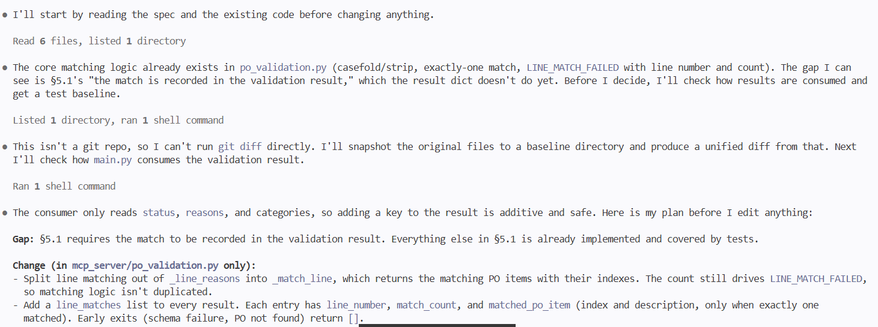
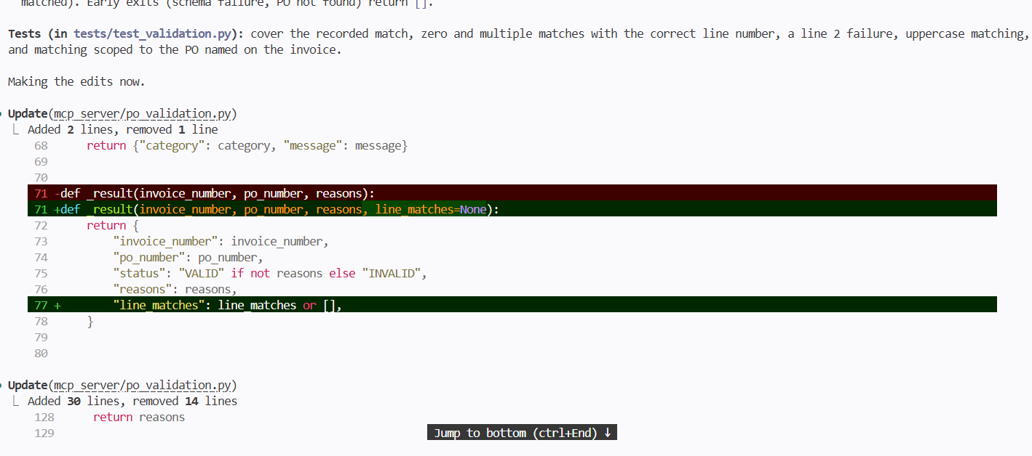
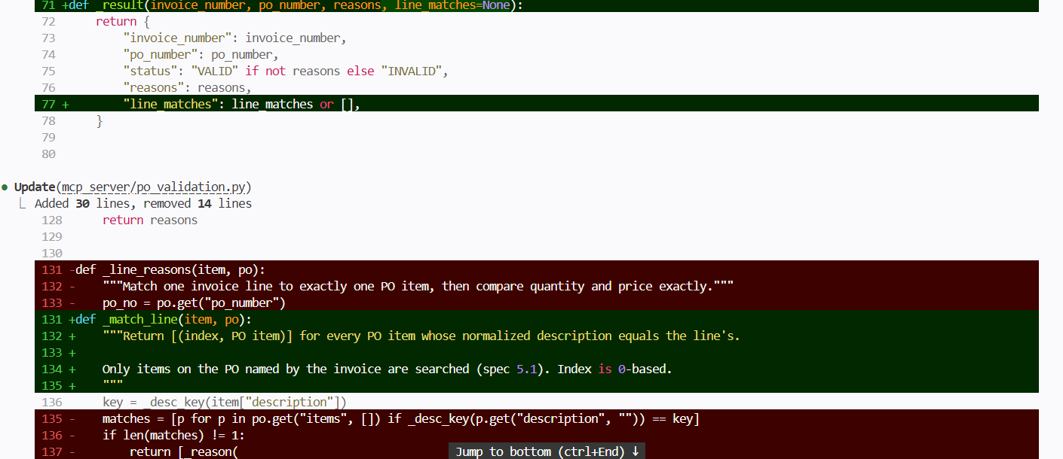
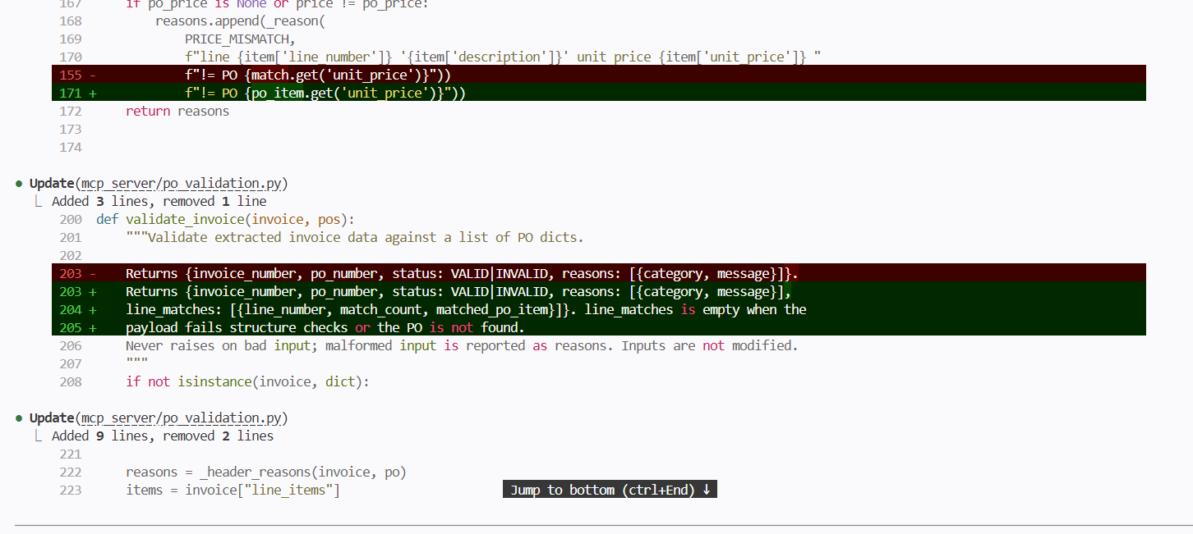
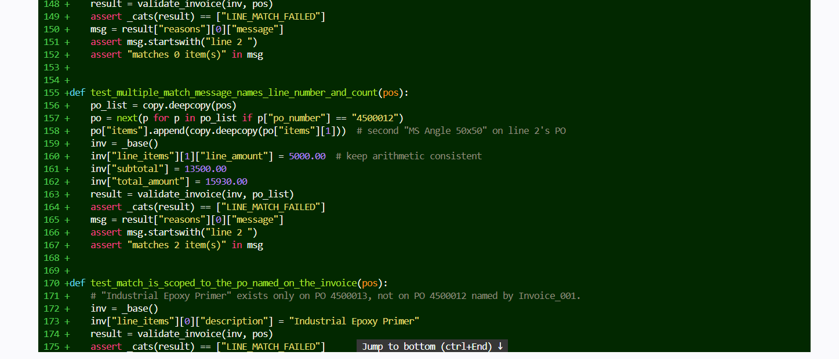
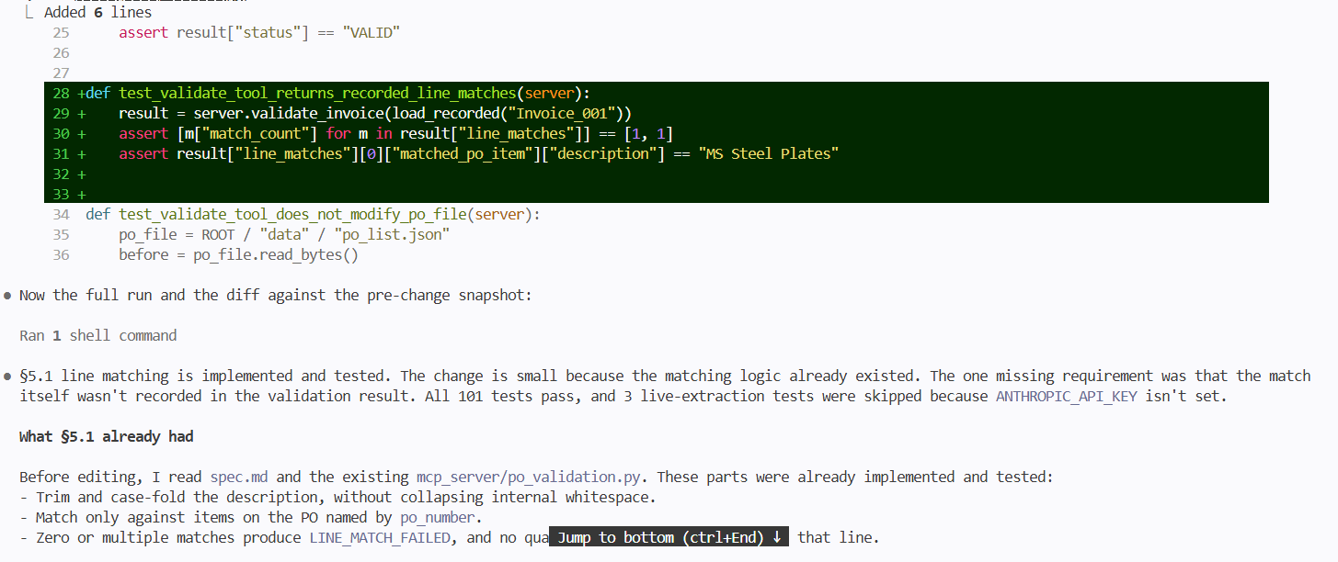
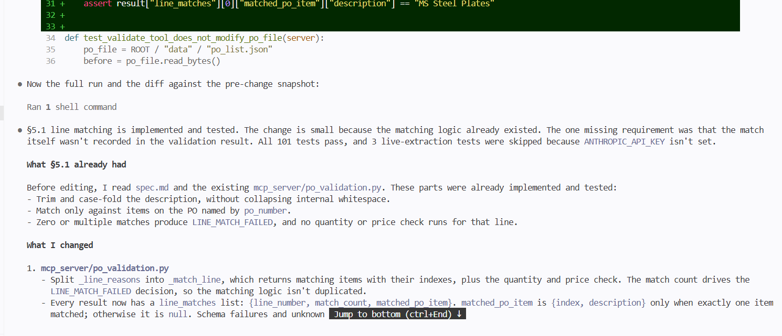
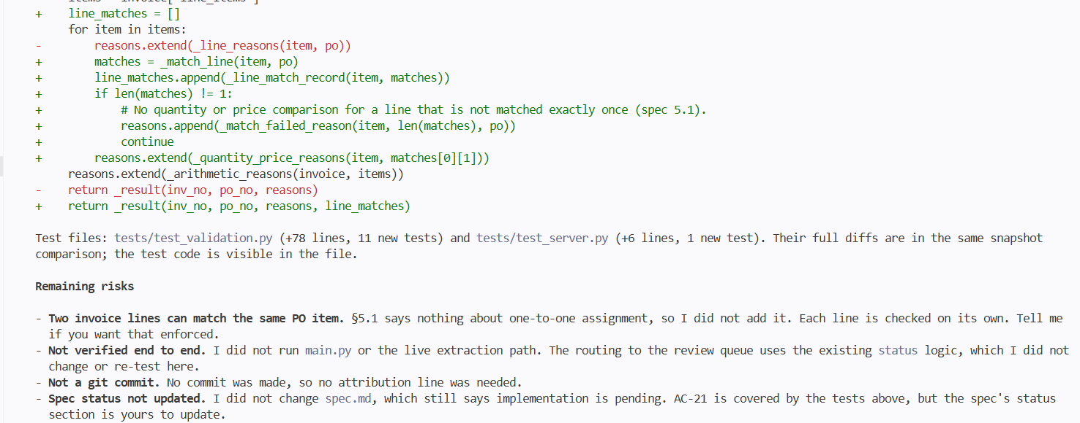

The prompt for codex:
Read spec.md and inspect the existing project. Implement the PO line matching requirements in §5.1. Add tests for zero, one and multiple matches, including case and surrounding whitespace. Show the Git diff and test results.

